JAGAT J L

Module 6 - Spring Data JPA with Spring Boot, Hibernate
Spring Data JPA - Difference between JPA, Hibernate and Spring Data JPA
Project Structure
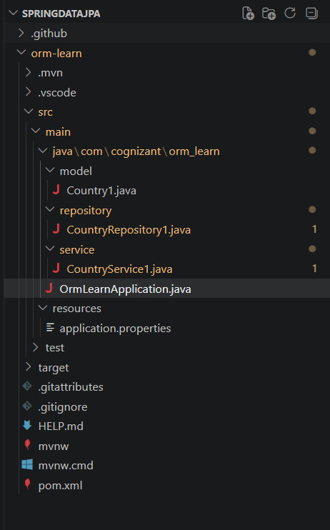
Entity
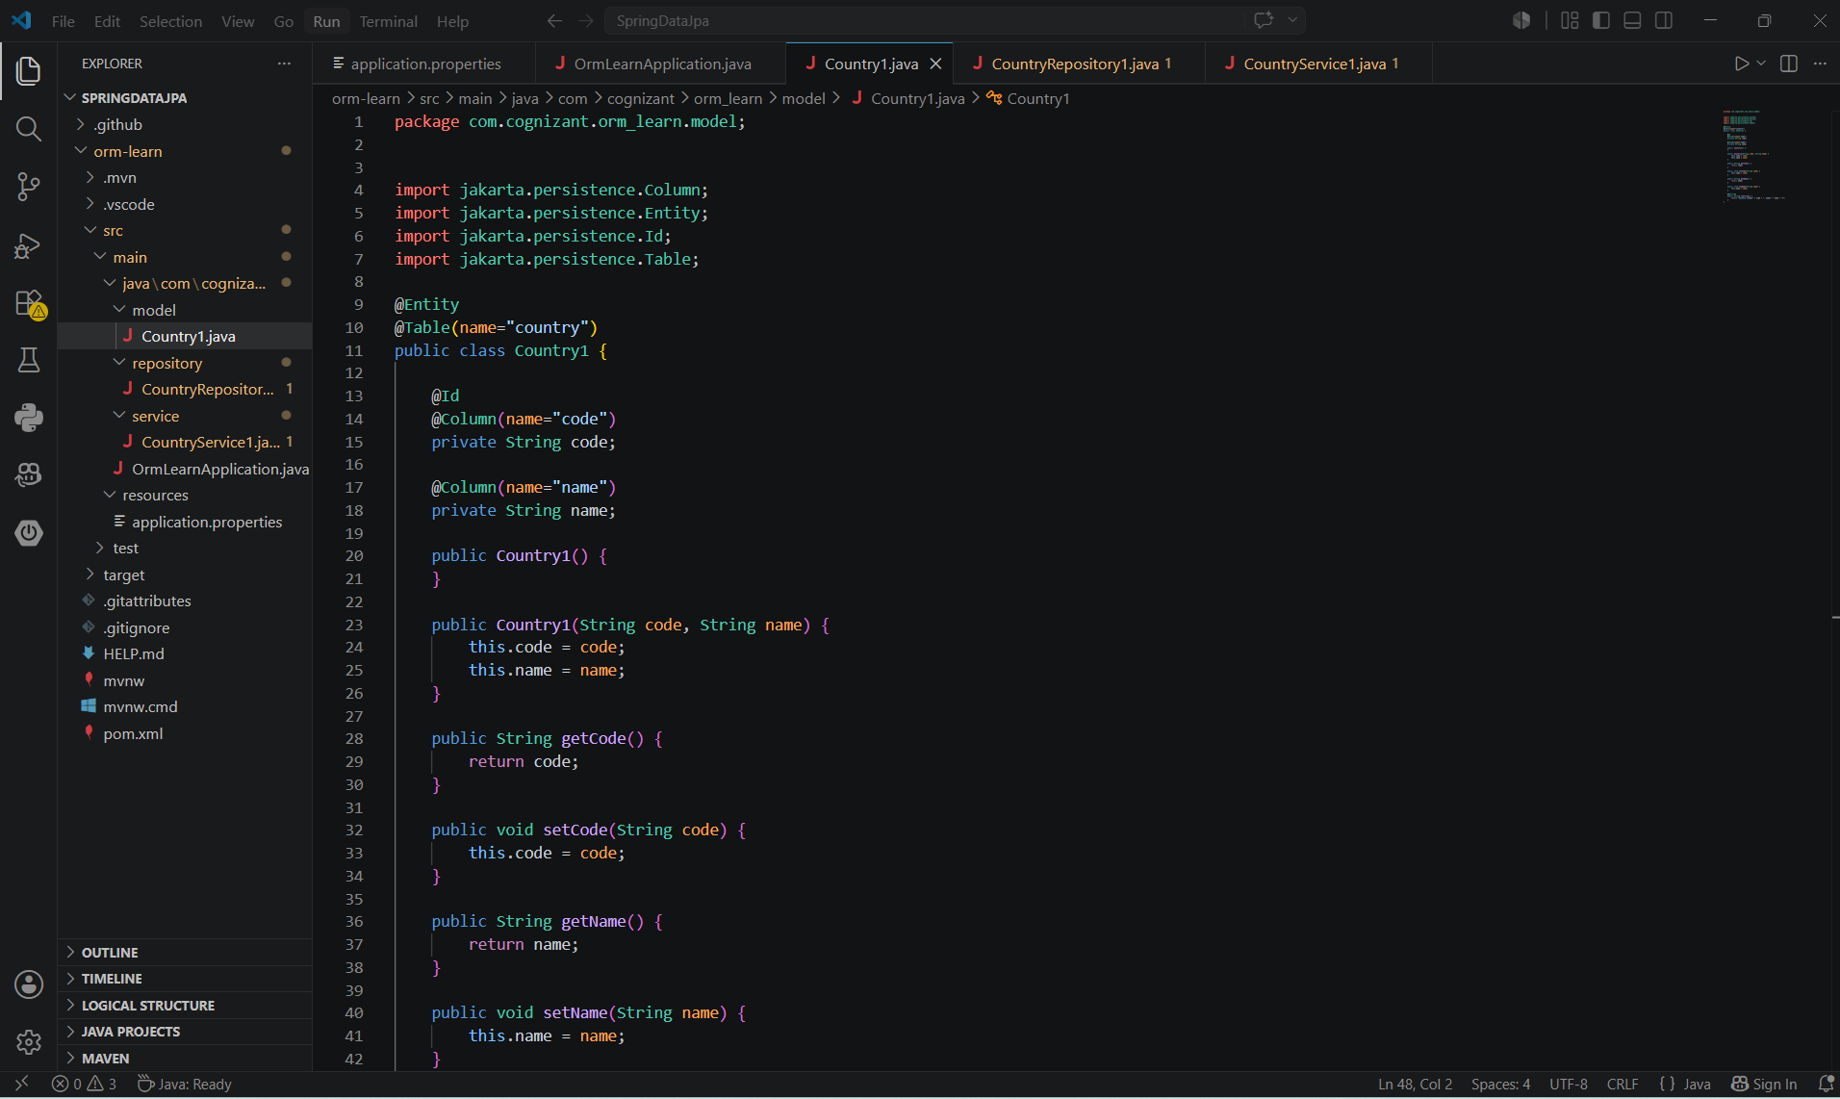
Repository
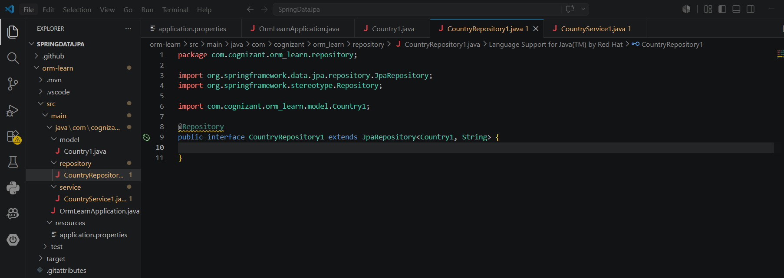
Service
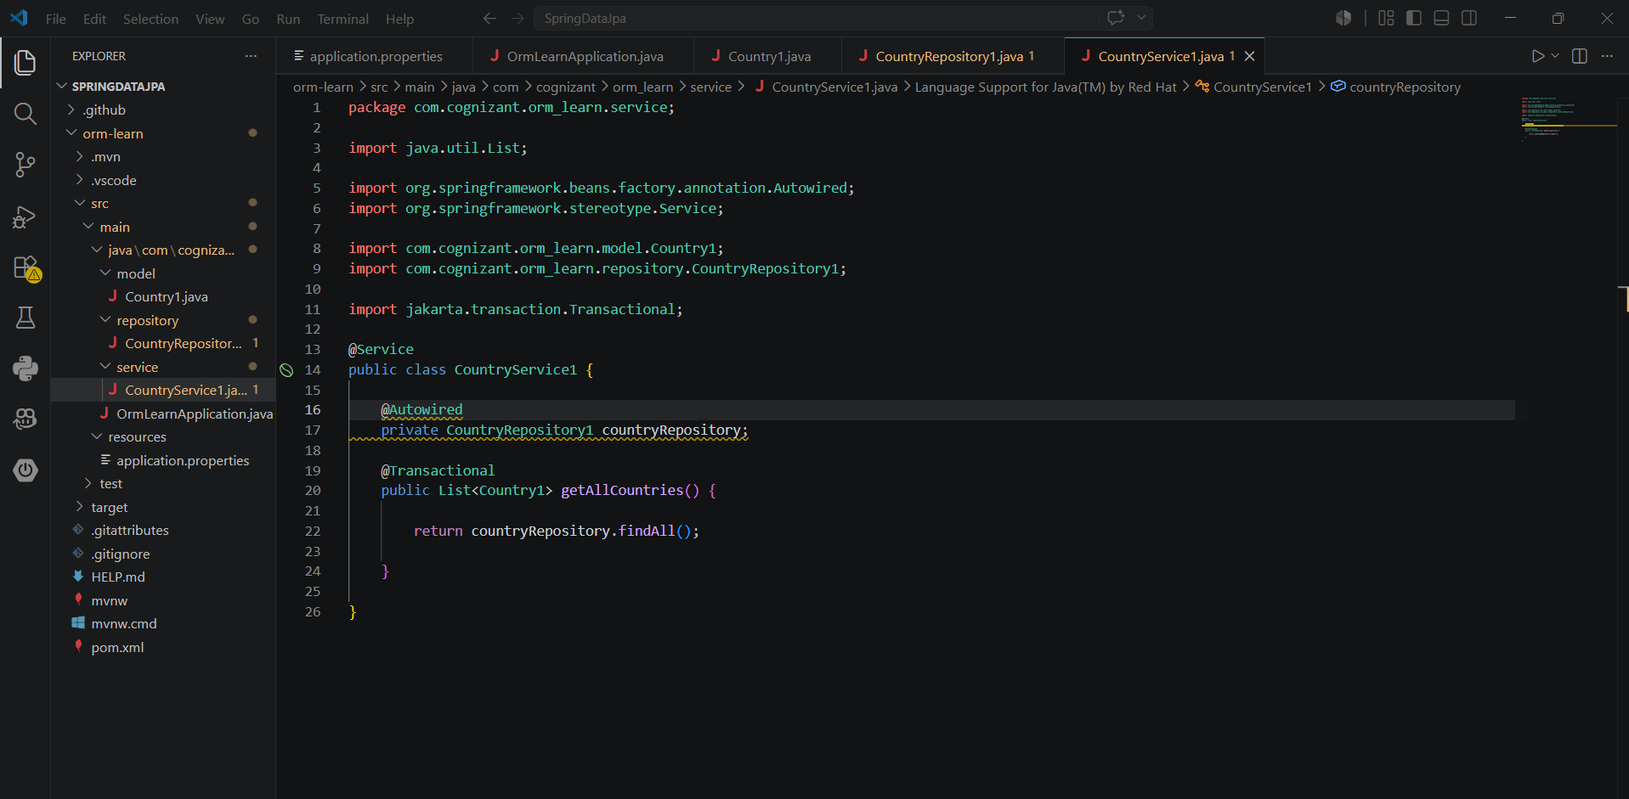
Output
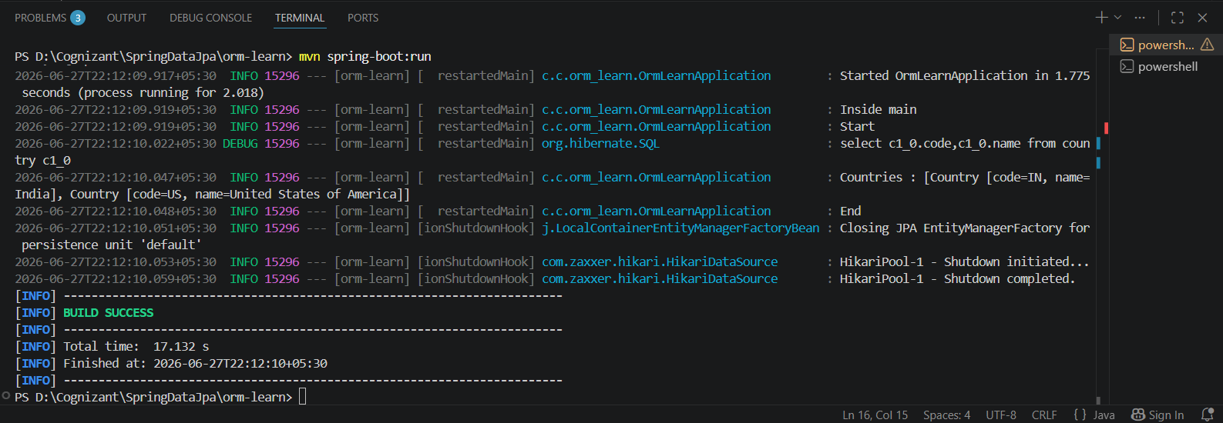
Explanation
Java Persistence API (JPA)
Definition
Java Persistence API (JPA) is a Java specification (JSR 338) for object-relational mapping (ORM). It defines a standard way to map Java objects to database tables.
Features
- Standard Java specification for persistence.
- Defines annotations such as @Entity, @Table, @Id, and @Column.
- Does not provide its own implementation.
- Requires an implementation such as Hibernate.
Advantages
- Database independent.
- Standardized API.
- Easy migration between different JPA providers.
Hibernate
Definition
Hibernate is a popular ORM framework that implements the JPA specification.
Features
- Complete implementation of JPA.
- Converts Java objects into database records automatically.
- Supports HQL (Hibernate Query Language).
- Handles caching, lazy loading, and transaction management.
Advantages
- Reduces SQL coding.
- Automatic table mapping.
- Better performance with caching.
- Supports advanced ORM features.
Spring Data JPA
Definition
Spring Data JPA is a Spring module built on top of JPA that reduces boilerplate code required for database operations.
Features
- Uses JPA implementation (such as Hibernate).
- Automatically generates CRUD operations.
- Provides repository interfaces.
- Simplifies transaction management using @Transactional.
- Supports custom query methods.
Advantages
- Minimal coding.
- Faster application development.
- Automatic repository implementation.
- Easy integration with Spring Boot.

